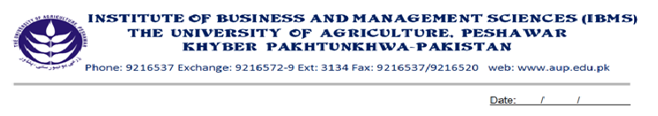
Programe: BS(CS)-VII
Course Name: Compiler Construction
Course Code: CS-602
Session: 2009-2012
Credit Hours: 03
Total Weeks: 16

Total Hours: 48

Course Objectives
After completing this course the students will be able to understand the basic concepts of compiler constructions, its phases, types and complexity, although few students are likely to build or even maintain a compiler fro a major programming language, they can profitably apply the idea and techniques to general software designs. The major topics in complier design are covered in depth in this course.

Week-1
-Compiler Basics
-Phases of Compilation

Week-2
-Cousins of Compiler

Week-3
-The Grouping of Phases
-Compiler Constructions tools

Week-4
-Lexical Analysis
-Role of the Lexical Analyzer
-Input Buffer Management

Week-5
-Regular Expression
-Conversion from Regular Language to Regular Expression

Week-6
-Non-Deterministic Finite Automata
-Deterministic Finite Automata
-Conversion of Non-Deterministic finite Automata to Deterministic
Finite Automata

Week-7
-Conversion of Non-Deterministic Finite Automata to Deterministic
Finite Automata
-E-Closure Method
Week-8
-Issues in Scanning
-Insignificant blanks, composite tokens, multiple character look ahead,
-Fixed Input format, reserved words, Case sensitivity,
-Entry of identifiers into a symbol table, lexical errors, Scanner termination

Week-9
-The Role of Parser
-Syntax Error Handing
-Syntax Error Recovery Strategies
-Panic Mode
-Phrase Level
-Error Production
-Global Correction

Week-10
-Context Free Grammar
-Types of Derivations
-Leftmost Derivation
-Rightmost derivation
-Derivation Tree

Week-11-12
-Problems of Grammar
-Ambiguity, left recursion, common Prefixes
-Eliminating Ambiguity
-Eliminating of left Recursion
-Left Factoring

Week-13
-Types of Parsing
-Top down Parsing
-Recursive Descent parsing
-Predictive Parsing

Week-14
-Transition diagrams for predictive parsers No Recursive Predictive parsers
-No Recursive Predictive Parsing

Week-15
-First, Follow, Predict Sets
-Construction of Predictive Parse Table

Week-16
-REVISION

Total Marks: 100
Recommended Books
1. Compiler by Alfred V. Aho, Ravi, Sehti, Jeffrev D. Ullman
2. Introduction to computer theory by Daniel I.A. Chen
3. Fisher. Crafting A compiler with c. Addison-wesley.

